Library Management System

Software Requirements Specification

Version 1.01

9th April 2019

Ng Jie Hui

**Table of Contents**

1. Introduction 1

1.1 Purpose 1

1.2 Scope 1

1.3 Definitions, Acronyms, and Abbreviations 1

1.4 References 1

1.5 Overview 1

2. General Description 2

2.1 Product Perspective 2

2.2 Product Functions 3

2.3 User Characteristics 3

2.4 General Constraints 3

2.5 Assumptions and Dependencies 3

3. Specific Requirements 4

3.1 Functional Requirements 4

3.1.1 Login 4

3.1.2 Search Feature 4

3.1.3 Librarian Control Panel 4

3.1.4 Book Reservation and renewal 4

3.1.5 Membership 4

3.1.6 Settings 5

3.2 External Interface Requirements 5

3.2.1 User Interface 5

3.2.2 Hardware Interface 5

3.2.4 Software Interfacel 5

3.3 Performance Requirements 5

3.4 Design Constraints 5

3.5 Database requirements 5

# 1. Introduction

## 1.1 Purpose

This SRS (Software Requirement Specification) serves as a contract between the development team and NNLB (Not National Library Board). The SRS highlights the requirements for the library management system, detailing the functional and non-functional aspects. This SRS provides an easy maintenance system as required by the client, as well as including several library features.

## 1.2 Scope

LMS (Library Management System) serves to update the manual library system into a fully functional web-based application intended for usage for both NNLB librarians and users.

The product is designed to complement and/or replace most manual library processes. These processes include: account details, availability of books, maximum limit for borrowing, book management inclusive of borrowing, renewing and reserving. A comprehensive catalogue is also implemented to aid librarians in book management.

LMS is easily adjustable, allowing for NNLB to add on any further necessary requirement in the future. LMS is created using C#, a programming language that is fast, simple, modern and easily scalable for bigger projects.

## 1.3 Definitions, Acronyms, and Abbreviations

*SRS – Software Requirement Specifications*

*NNLB – Not National Library Board*

*LMS – Library Management System*

*SQL – Structured Query Language*

*RAM – Random Access Memory*

## 1.4 References

## 1.5 Overview

The rest of the SRS contains the general description and specific requirements of LMS. The general description section describes the product perspective, product functions, user characteristics, general constraints and the assumptions and dependencies involved. The specific requirements details the functional requirements, external interface requirements, performance requirements, design constraints and attributes.

# 2. General Description

*This section of the SRS should describe the general factors that affect 'the product and its requirements. It should be made clear that this section does not state specific requirements; it only makes those requirements easier to understand.*

## 2.1 Product Perspective

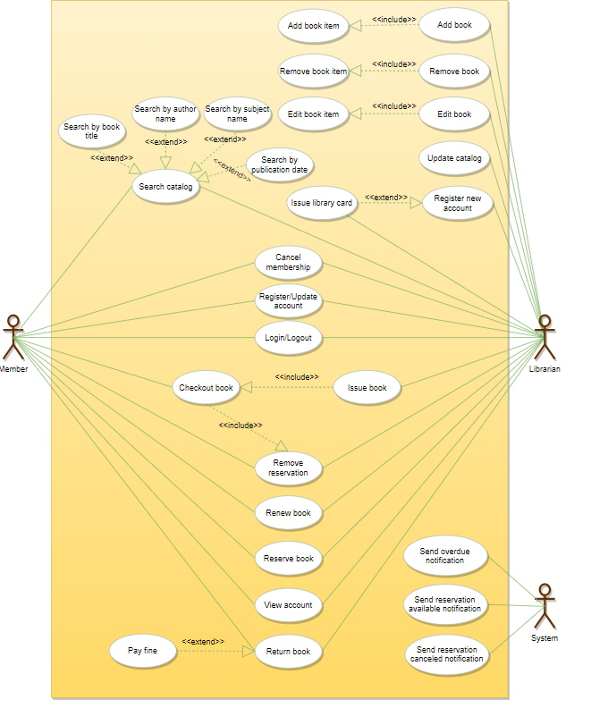

Block diagram showing the major components of LMS, interconnections and external interface.

The system is not wholly independent but rather is meant to complement basic library process which is impossible to automate, such as borrowing and returning of books.

## 2.2 Product Functions

These are the functions of LMS:

* Library Catalogue: the central part of the software which simulates the actual library, taking notes of which books are reserved, returned, etc.
* Account: Consists of either the user or librarian
* Book reservation: Manages reservations of book items
* Book renewal: Manages renewal of book items
* Membership: Allows users to upgrade their membership status, which would increase book loan amount
* Language: LMS contains 4 languages; English, Mandarin Chinese, Malay and Tamil.

## 2.3 User Characteristics

LMS is intended to be used by user who has a basic grasp of either English, Chinese, Malay or Tamil. The users should also be able to access the web and have simple knowledge of web functions.

Librarians should also be able to understand one of four languages and have a more advanced understanding of the web application. Programming knowledge is not necessary.

## 2.4 General Constraints

## LMS is to be run 24/7 on a data server. The product also must account for mismanagement where the system failed to update a book return. In such cases fines might be accumulated unjustly. LMS should also work properly where users access the website through their phones.

## 2.5 Assumptions and Dependencies

Assumptions

* Users have basic access to the internet and internet connection
* Users have login information and also additional steps to ensure self-verification
* System has a search system and easy to use interface

Dependencies

* The librarians have a proper understanding of the system
* The librarians do not abuse the system
* The information of users login and other sensitive information and stored in a database which is very well protected.

# 3. Specific Requirements

## 3.1 Functional Requirements

This section describes specific features of the software project. If desired, some requirements may be specified in the use-case format and listed in the Use Cases Section.

### 3.1.1 Login

Introduction - The user is prompted to enter a username and password.

Input and Output - Password is masked as it is typed.

The user will have three chance to enter the correct username/password combination before the account gets locked.

Exception Handling - If the account gets locked out, users would have to call the help center for verification.

### 3.1.2 Search Feature

Introduction - The user is able to search through the library catalogue for specific books. Books are registered via a specific ID.

Input and Output - The user can search via the book unique ID, the book title or author.

The user is also able to filter via languages and sort by categories.

Exception Handling – If the book is not found, an error message will pop out

### 3.1.3 Librarian Control Panel

Introduction - The librarian controls the book and users within the database.

Input and Output – The librarian is able to add or remove users and books.

Exception Handling – The librarian needs to update the database in case of missing books, blacklisted users and other administrative events.

### 3.1.4 Book reservation and renewal

Introduction - The user is able to reserve and renew books.

Input and Output - The user reserves and renew books via the LMS. Each user is only able to reserve 2 books and renew once.

Exception Handling – if the user attempts to reserves more than 2 book and renew more than once, an error message will pop out.

**3.1.5 Membership**

Introduction - The user is able to upgrade their accounts to premium.

Input and output – By paying a fee of $20 per month, the user is able to increase their borrowing limit from 8 to 16.

Exception Handling – If the user deactivates the premium account, he is able to keep the maximum amount of 16 books till the books loan period ends.

**3.1.6 Settings**

Introduction - The user is able to switch between 4 different languages; English, Chinese, Malay and Tamil.

Input and Output – The user is able to switch between the 4 languages via the settings in the LMS

Exception Handling – The default language will be in English, and if the page is refreshed it will return to the default language.

## 3.2 External Interface Requirements

### 3.2.1 User Interfaces

LMS provides good graphical interface for the user and administrator. It has a simple white background and button controls are brown. Fonts are 20 Arial to accommodate for visually impaired users. Book titles contains a hyperlink to a google search for the particular book.

### 3.2.2 Hardware Interfaces

Processor Speed: 2.2 GHz

Hard Disk: 10GB

RAM: 256 MB or more

### 3.2.3 Software Interfaces

Operating System: Windows 7 and above

Language: C#

Database: MS SQL Server (Back End)

## 3.3 Performance Requirements

### System should be fast and reliable. System downtime should not exceed 5 minutes per day. Maintenance should be held between 2-6 AM. Database should be secure such that users is unable to access other users’ password. LMS should be able to run fine when users access the system via web mobile. Font and indentation similarly are scaled appropriately.

## 3.4 Design Constraints

The librarians should have access to the database to rectify any issues that might arise due to server crash, power failures, and destroyed books. The system capacity should be designed to be 3x the library size to accommodate for future changes. The data server should also be designed such that integration of a second data server is possible for future proofing.

**3.5 Database Requirements**

The database should catalog the different books via their unique ID.

|  |  |  |  |  |  |
| --- | --- | --- | --- | --- | --- |
| Unique ID | Title | Loan Status | Author | Category | Language |
| 321442 | Men’s Health | Available | - | Magazine | English |
| 442232 | Harry Potter | On Loan | JK Rowling | Novel | Chinese |
| 536732 | Artemis Fowl | Reserved | Eoin Colfer | Young Adult | Malay |
| 312556 | X-Men | Available | Stan Lee | Comics | Tamil |
| 634632 | X-Men | On Loan | Stan Lee | Comics | Tamil |

The database also allows for users to search for a particular book and find relevant information such as ID, Title, Loan Status, Author, Category and language. The system should also allow for duplicate books, meaning that 2 books of the same title should have 2 unique ID. The database should also prop the available books on top of the loaned ones, in the case where one is loaned, and one is available.

A second database is also required to implement the user names, ID, membership status, any outstanding fines, any books borrowed or reserved.

|  |  |  |  |  |  |
| --- | --- | --- | --- | --- | --- |
| Name | UserID | Membership | Fines | Borrowed | Reserved |
| Jack | 421421 | Basic | NIL | Star Trek | NIL |
| Tim | 332134 | Basic | $1.93 | NIL | NIL |
| Hart | 568543 | Premium | NIL | NIL | Batman |

The fines system should be automatic, allowing for daily increments by itself.